**University College Dublin**

**School of Mechanical & Materials Engineering**

MEEN10050 Energy Engineering 2013-14

Group Assignment

**Heating Energy Requirements for a Room over 7 Consecutive Days**

**By**

**Group 05**

**Aaron Collier / 13363011**

**Eibhan Joyce / 13447252**

**Fergal Lonergan / 13456938**

Lecturers:

Dr. David Timoney

Dr. James O’Donnell

Dublin 2014

‘We, the team members shown on this cover page, confirm that the work presented within this report is our own original work and that all contributed to the work.’

# Abstract

The investigation was carried out in order to find the amount of energy needed to maintain an office at 22oC.

The process involved in carrying out the investigation was divided into the following steps:

1. Room selection - the selection of a suitable room in which to carry out the experiment.
2. Detailing and measuring of room - this involved getting dimensions and a floor plan of the room as well as documenting the material makeup of the walls, floor and ceiling.
3. Equations – equations where then used to measure the heat lost and gained by the room to its surroundings making a few assumptions, i.e. the energy input, to obtain calculations.
4. Graphing- the findings where then graphed to make interpretation of the data easier to understand.

After completing the investigation it was found:

1. The room lost on average 127.05W to the surrounding area, i.e. to the exterior of the building, the floor etc.
2. The largest contributor to heat loss was the ventilation.
3. An additional radiator was too excessive to maintain a temperature of 22°C in the room.
4. The addition of 50mm of polyurethane insulation barely affected the room as it was already well insulated.

# Table of Contents

Abstract i

Table of Contents ii

1. Introduction 2

Objectives: 2

2. Methodology 2

2.1 Room and building description 4

2.2 External surface description 7

2.2.1 External wall 7

2.2.2 External window 8

2.2.3 Floor 10

2.3 Ambient air temperature 11

2.4 Heat losses and heat gains 12

2.4.1 Ventilation heat losses 13

2.4.2 Internal heat gains 13

2.4.3 Heat losses from the window 14

2.4.4 Heat losses from the wall 14

2.4.5 Heat losses through the floor 14

3. Results and analysis 15

3.1 Heat losses 15

3.2 Interior and exterior temperatures of external building elements 16

3.3 Maximum heating load and radiator capacity 16

3.4 Additional insulation 17

4. Conclusions 18

Reference 19

Appendix A 20

Appendix B 20

# Introduction

**Introduction**

This study was carried out in order to investigate the energy requirements for a room at a constant temperature over 7 consecutive days. In order to do this the internal and external dimensions of the room and where measured and then the composition of the internal and external walls as well as the ceiling and floor where discovered. The heat transfer rates through all of the construction materials in the room and the heat input to the room where then calculated. Also the difference in heat transfer rates and heating loads through the construction materials were calculated after an extra layer of insulation was added.

The room chosen had one external wall which was exposed to variations in external air temperatures and was studied over a twenty four hour period for seven consecutive days. A plan of the room and house was drawn up on C.A.D. showing the composition of the walls, ceiling and floor along with the thickness of all materials used. Measurements for volume of air in the room and surface area of the walls and windows were then taken together with the U values of the materials used.

This investigation should give you a good insight into the heating requirements to maintain a temperature of 22 degrees Celsius and the difference in these requirements when an additional layer of insulation is added for a typical Irish home in early Spring.

**Background**

Investigations such as this one are becoming more and more popular with people attempting to monitor and reduce their energy usage. The Government’s Climate Change Response Bill 2010 contains a plan to reduce Ireland’s emissions by 2.5 % annually until 2020. To do this Ireland must shift from fossil fuels to alternative renewable sources. The government also then looked at reducing our energy consumption by giving grants for insulation in homes so that there is less heat lost to the atmosphere. Recently extensive research has been carried out into improving the insulating properties of construction materials, so much so that nowadays almost all materials used in construction add to the houses’ insulating capabilities. This report give a comprehensive representation of where heat is lost in our chosen room and the materials through which the most heat is lost. It also displays the improvement in U-value of the wall after an extra layer of insulation is added.

**Layout of report**

The report is laid out as follows:

1. Cover page: The opening page of report. States who completed the report and its’ title.
2. Abstract: Gives a quick description of the report and the steps taken to complete it.
3. Table of contents: Gives the page numbers of where each section is in the report.
4. Introduction: Introduces the reasons for undertaking the investigation and gives a short background to the report.
5. Objectives: Lays out the steps and goals of the report in order of completion.
6. Methodology: Tells the reader what specific objectives were set and they were met.
7. Results & Analysis: Theses are found after doing the calculations and are then interpreted and graphed.
8. Conclusions: The conclusions outline the main findings. It directs the reader to the most important findings, and as the last thing the reader sees, it helps to fix these key points in memory. It reiterates the most important points that have come up in the results section.
9. Reference: This cites all material used to help with the report.
10. Appendix A: States how much each person contributed to the report and how.
11. Appendix B: Includes any additional information on the area the report was carried out on but that is not necessary in the context of the report.

# Methodology

# Objectives:

1. Meet to decide type of room and delegation of roles for project.
2. Measurement of room’s internal and external dimensions.
3. Meeting with the building surveyor who designed the house to review plans and find out composition of walls ceiling and floor.
4. Drawing up of the room’s floor plan and section views of the building showing composition of the room’s walls and floor and ceiling.
5. Pictures taken of room and building showing both internal and external walls.
6. Discovery of thermal resistance values and u-values for each material.
7. Calculation of:
8. Total resistance and u-values for walls and ceiling and floor.
9. Ambient air temperature in the room.
10. Surface area of the walls, floor and ceiling.
11. Internal surface temperatures of the walls, ceiling and floors.
12. External surface temperatures of the walls, ceiling and floors.
13. Heat losses to ventilation.
14. Heat lost to external wall.
15. Heat lost to internal wall.
16. Heat lost to window.
17. Heat lost to ceiling.
18. Heat lost to floor.
19. Total amount of heat energy lost to surroundings.
20. Heat gained from electrical devices in room.
21. Heat gained from radiator.
22. Total heat gained.
23. Interpretation of results
24. Graphing of results
25. New calculations including extra insulation:
    1. Total resistance and u-values for walls and ceiling and floor.
    2. Ambient air temperature in the room.
    3. Surface area of the walls, floor and ceiling.
    4. Internal surface temperatures of the walls, ceiling and floors.
    5. External surface temperatures of the walls, ceiling and floors.
    6. Heat losses to ventilation.
    7. Heat lost to external wall.
    8. Heat lost to internal wall.
    9. Heat lost to window.
    10. Heat lost to ceiling.
    11. Heat lost to floor.
    12. Total amount of heat energy lost to surroundings.
    13. Heat gained from electrical devices in room.
    14. Heat gained from radiator.
    15. Total heat gained.
26. Interpretation of new results
27. Graphing of new results
28. Writing of the report
29. Submit report for 17:00, Monday the 24th of February.

**Flow Chart of steps taken:**

**Building and Room selection**

**Ambient Air Temperature calculation**

U-values and heat transfer area

Room volume and floor area

Building heat losses

Ventilation heat losses

Internal heat gains

Radiators size and number

Interior and exterior surface temperatures

***Figure 2.1:*** *Work flow diagram of the methodology followed*

## Room and building description

The room is a north facing, ground floor music / reading room. It is part of a 1992, two storey, detached house in the suburbs of a medium sized, market town in Co. Monaghan. The room is situated at the front of the house and leads off the entrance hall. It is only ever used for recreational use and as a result is not subjected to frequent traffic. The room is x m2 (3.6m x 3.7m x 2.6m). It has one exterior wall and three interior walls. It is heated by a single radiator on the external wall underneath a window. It is also generally quite a warm room. Also present photographs of the building and the room (depicting the external surface) and a floor plan of the room.

**IMAGES OF OUR SELECTED PROJECT ROOM**

**OUTSIDE OF HOUSE AND ROOM**

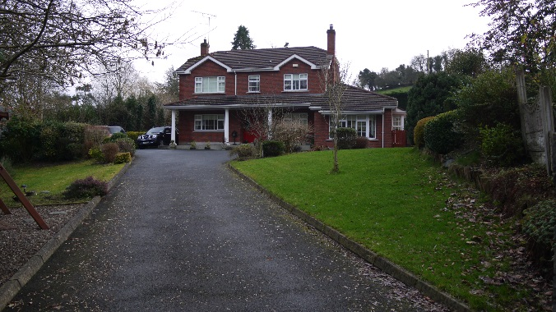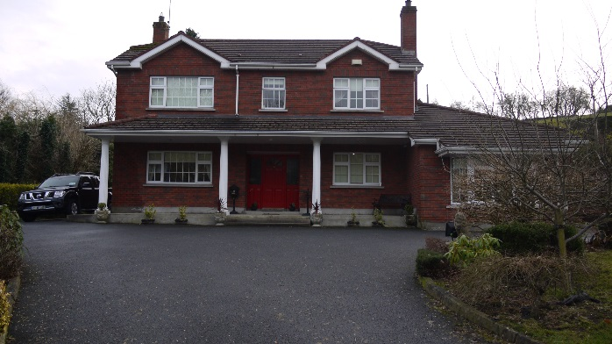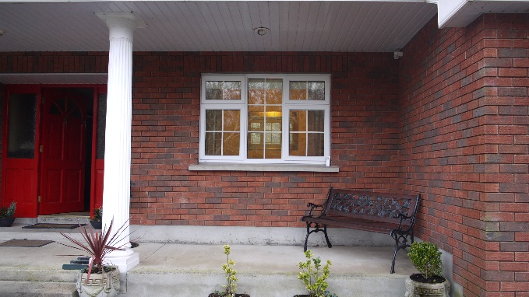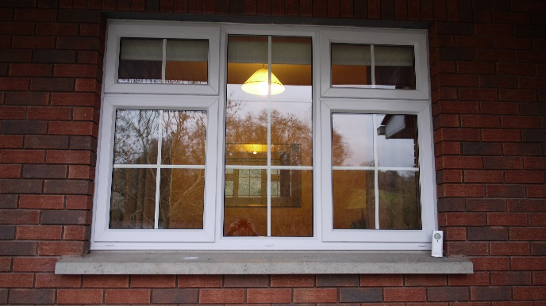

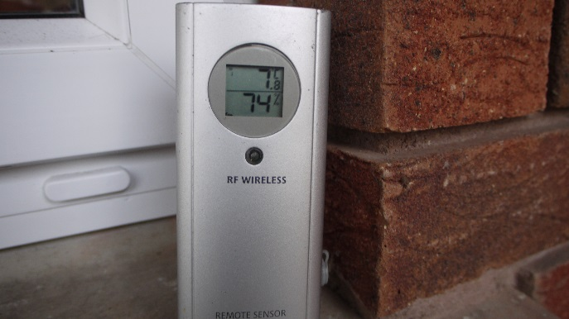

**INSIDE OF ROOM**

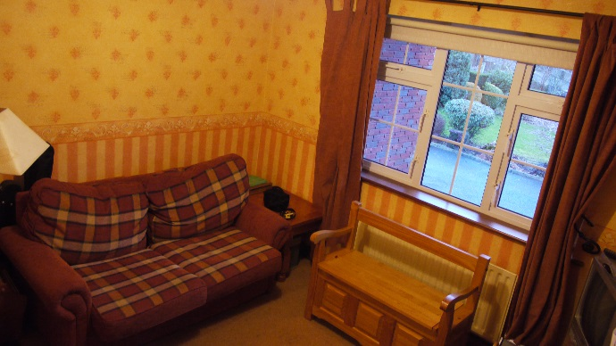 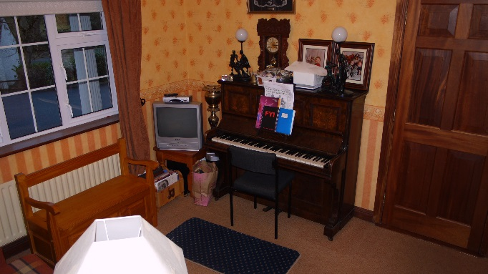 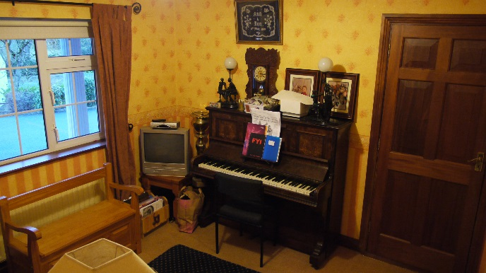 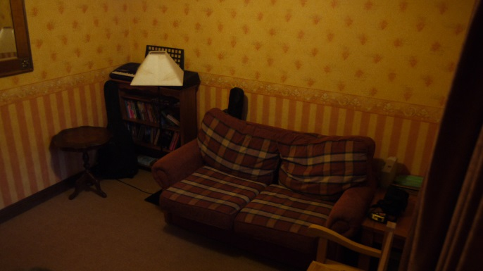 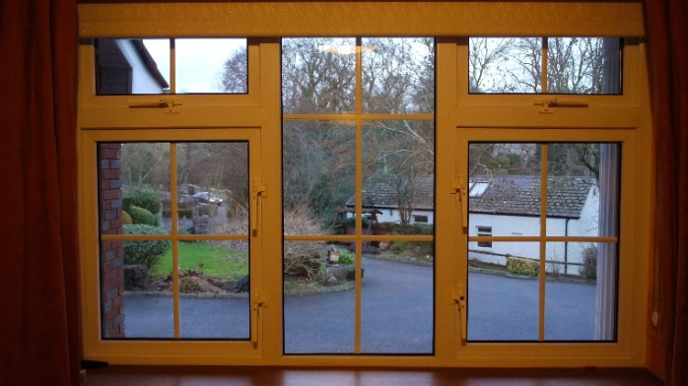 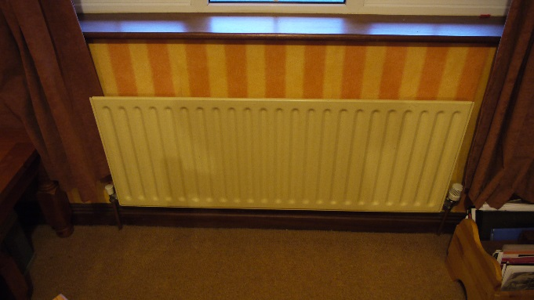

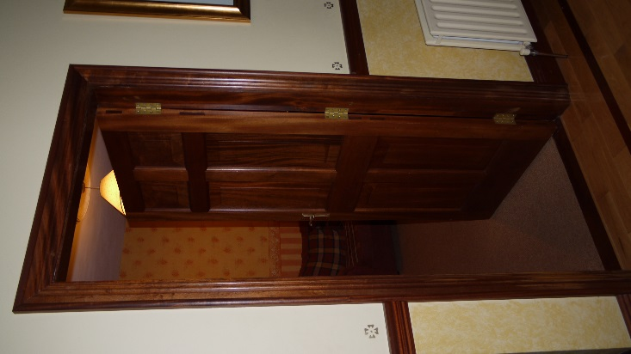

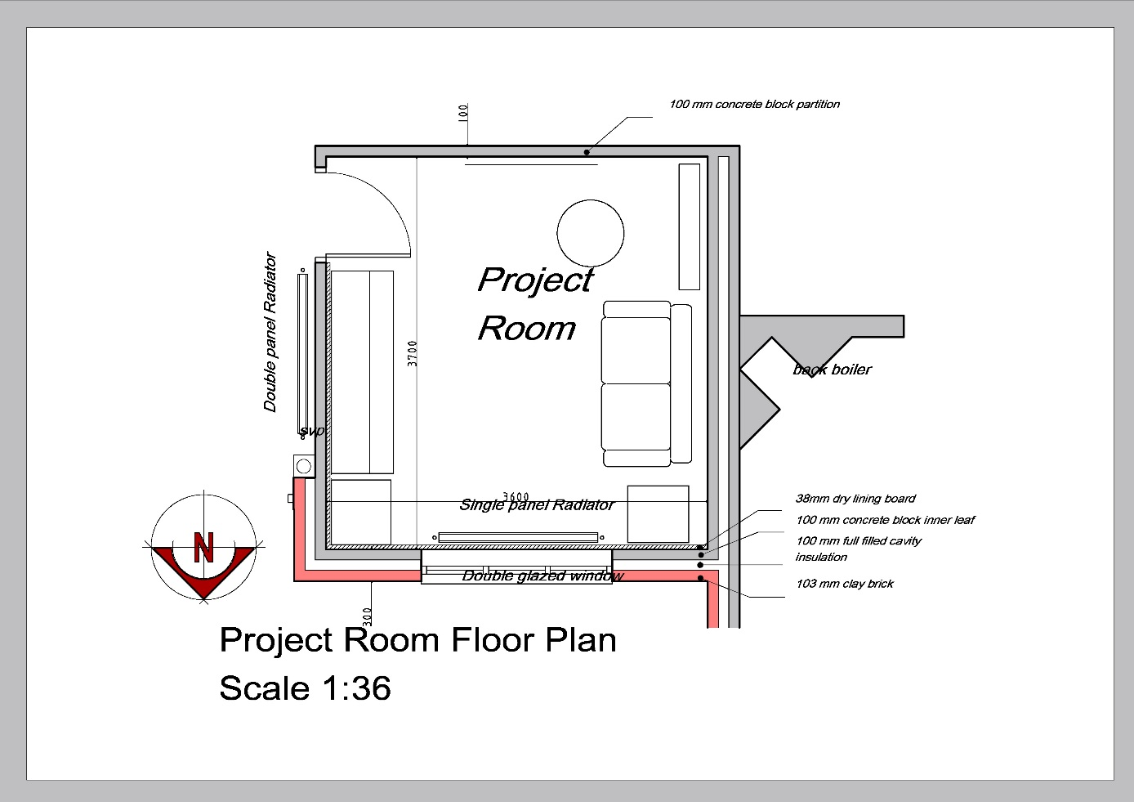

## External surface description

The external surface is a red brick external leaf on a cavity wall. The inner leaf is concrete block work with an insulated panel as well as cavity full fill insulation. There is a veranda overlooking the external surface and as a result it is not usually subjected to direct sunlight.

## External wall

|  |  |  |  |  |
| --- | --- | --- | --- | --- |
|  |  | Wall |  |  |
| Material | Thickness 'd' (m) | Thermal Conductivity 'k' (W/m*K) | Thermal Resistance 'R' (K/W) R=d/A*k(1) | U values (W/m2K) |
| Red Brick | 0.103 | 0.87 | 0.1184 | 8.446 |
| Concrete blocks | 0.1 | 0.55 | 0.1818 | 5.5 |
| Gypsum plaster board : split into |  |  |  |  |
| 1. Polyurethane insulation | 0.025 | 0.03 | 0.09 | 0.12 |
| 2. Plaster board | 0.12 | 0.2 | 0.6 | 1.667 |
| Added insulation | 0.05 | 0.03 | 0.18 | 5.47 |
| Polystyrene bead cavity full fill insulation (already there) | 0.1 | 0.03 | 3.33 | 0.3 |
|  |  |  |  |  |
| **Total Thermal Resistance RT (m2K/W)** |  | RT=Rsi+R1+R2+…+Rn+Rse | **4.32** |  |
| **Thermal Transmittance U(W/m2K)** |  | **U=1/A*RT** |  | 0.0254 |
| **Total Thermal Conductivity** |  |  | 0.231397876 |  |

*(1): for a heat transfer area of 1 m2*

**Thermal Resistance**

The thermal resistance was calculated by measuring the thickness of the material in metres (x) and dividing it by the thermal conductivity (k).

Rt = Thermal resistance (m^2k/W)

X = thickness (m)

k = Thermal conductivity

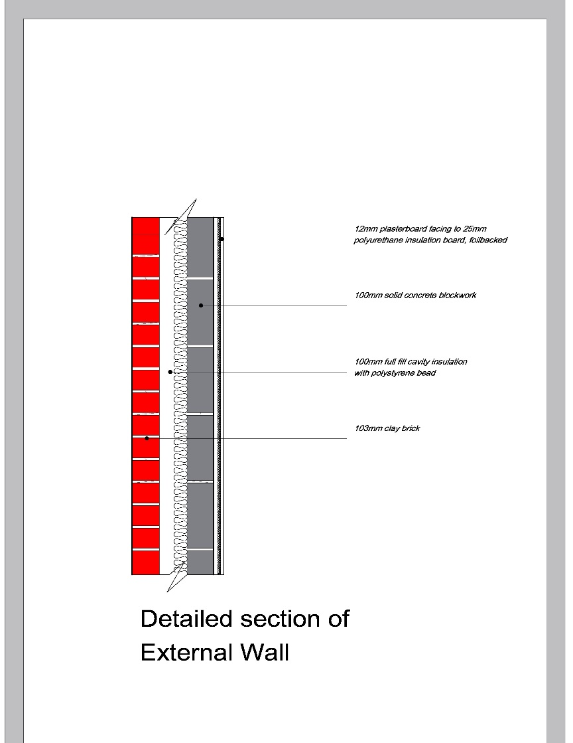

## External window

The window is double glazed UPVC 1.8m x 1.2m, split into five different sections. 2 (0.25x46.5) m, 2 (0.61x46.5) m and 1 (110x46.5) m. The outside sill is made of a concrete block ledge. A cross section of the window is essential reporting all the material layers. You should cite all the sources you have used to determine the thermal conductivities of the window materials. A table such as that shown in Table 2.1 is useful here also.

|  |  |  |  |  |
| --- | --- | --- | --- | --- |
|  |  | Window |  |  |
| Material | Thickness 'd' (m) | Thermal Conductivity 'k' (W/m*K) | Thermal Resistance 'R' (K/W) R=d/A*k(1) | U values (W/m2K) |
| Glass ( 2 panes ) | 0.006 | 0.96 | 0.00625 | 160 |
| PVC | 0.054 | 0.19 | 0.33 | 2.99 |
| Cavity | 0.012 | 0.024 | 0.5 | 2 |
|  |  |  |  |  |
| **Total Thermal Resistance RT (m2K/W)** |  | RT=Rsi+R1+R2+…+Rn+Rse | **0.50625** |  |
| **Thermal Transmittance U (W/m2K)** |  | U=1/A*RT |  | 0.91 |
| **Total Thermal Conductivity** |  |  | 1.975308642 |  |

***Table 2.2:*** *Calculation of the U-value for the window*

*(1): for a heat transfer area of 1 m2*

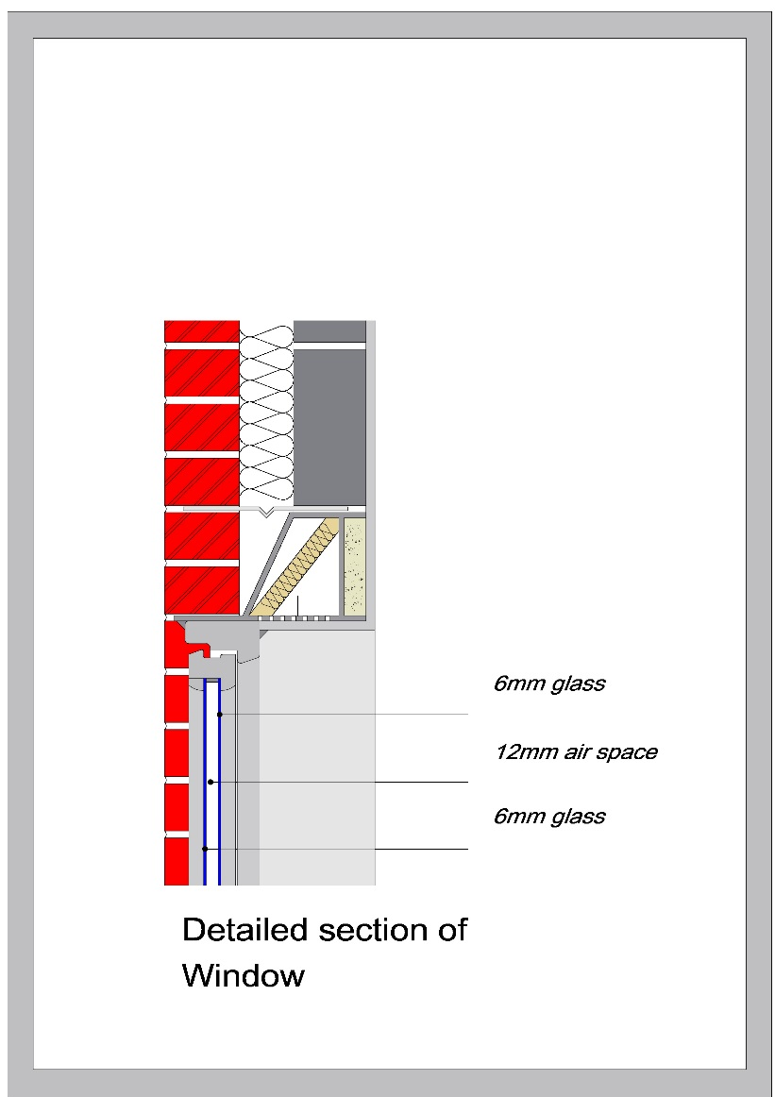

## Floor

The floor is carpet laid on top of a 50mm screed top layer. Then there is 100mm of concrete on top of 50mm of polystyrene insulation, all on top of a 200mm hard core concrete base. Its’ dimensions are 3.6m x 3.7m.

|  |  |  |  |  |
| --- | --- | --- | --- | --- |
|  |  | **Floor** |  |  |
| Material | Thickness (m) | Thermal Conductivity (W/mk) | Thermal Resistance (k/W) | U values |
| Hardcore | 0.2 | 1.4 | 0.14 | 7 |
| Polystyrene Insulation | 0.05 | 0.03 | 1.67 | 0.6 |
| Concrete | 0.1 | 0.55 | 0.18 | 5.5 |
| Screed | 0.05 | 0.2 | 0.25 | 4 |
|  |  |  |  |  |
| **Total Thermal Resistance RT (m2K/W)** |  | RT=Rsi+R1+R2+…+Rn+Rse | 2.24 |  |
| **Total U value of wall U (W/m2K)** |  | U=1/A*RT |  | 0.03 |
| **Total Thermal Conductivity** |  |  | 0.446161275 |  |

***Table 2.3:*** *Calculation of the U-value for the floor*

*(1): for a heat transfer area of 1 m2*

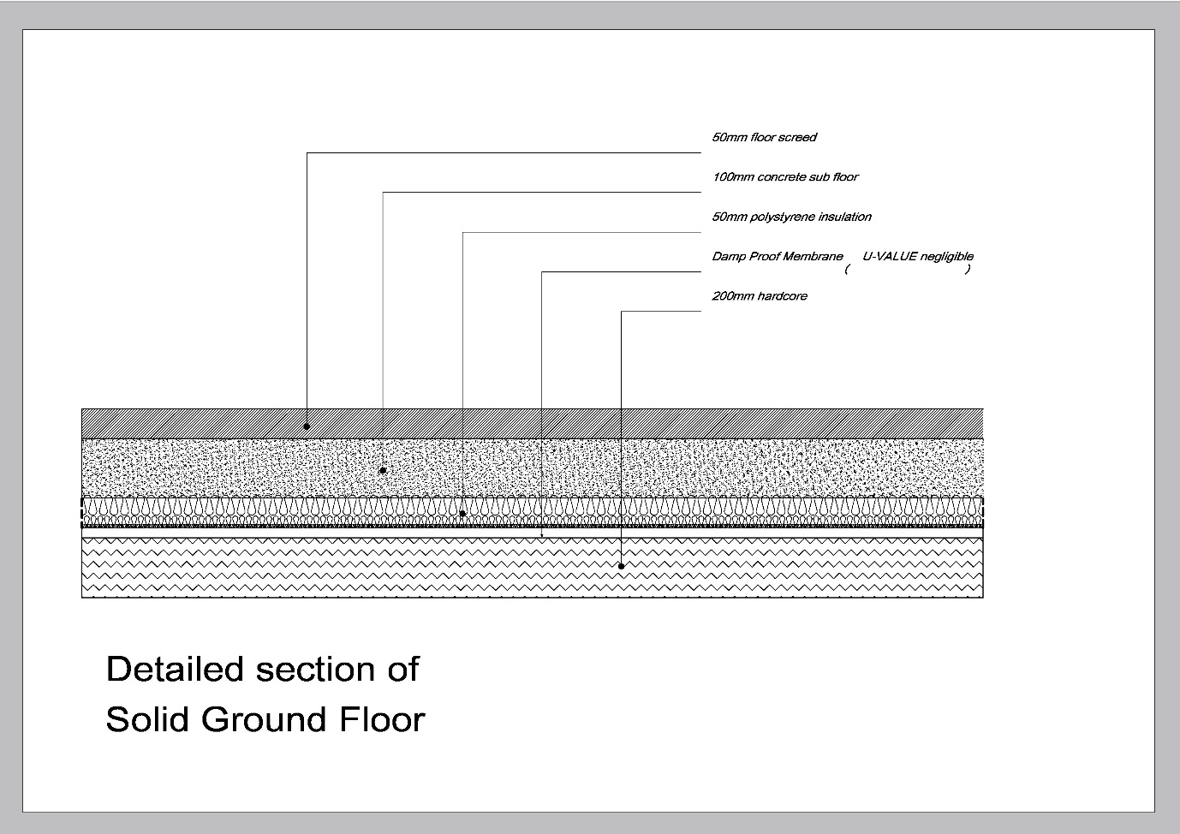

## Ambient air temperature

**The internal ambient air temperature (°C)**

The internal ambient air temperature of the room was presumed to be 22°C for the duration of the experiment.

**The External ambient air temperature (˚C)**

The external ambient air temperature is calculated by:

T = The external ambient temperature

A = The average of the last digit of the UCD student numbers of all students in the group (excluding any numbers ending in zero).

h = Hour of the day

d = Day of the week

## Heat losses and heat gains

**Thermal Resistance**

The thermal resistance was calculated by measuring the thickness of the material in metres (x) and dividing it by the thermal conductivity (k).

Rt = Thermal resistance (m^2k/W)

X = thickness (m)

k = Thermal conductivity

**Thermal Transmittance (U-value**)

Rt = Thermal resistance of the material

**Heat Transfer Rate**

Heat transfer rate through the wall, window, ceiling and floor:Top of Form

Bottom of Form

U = U-value of the material

Av = room temperature (22˚C)

T = External ambient temperature

**Heat Losses:**

The heat losses to be calculated were those through the outside wall, the window, the floor and the ventilation losses through the door and window.

**Heat Gains:**

The heat gains were presumed to be 8 watts per square metre of floor area and included the radiator, any heat gained from internal walls, any heat gained from electrical equipment in room, the radiator behind one of the walls and the back boiler behind another wall.

## Ventilation heat losses

The ventilation heat losses would have been through the door and the windows when open.

**Ventilation**

V = Volume of air in room

t = Hour in seconds

**Ventilation Heat Losses**

Heat transfer through ventilation is given by:

* = Heat Transfer

Specific Heat Capacity of Air (1005* )

= Density of Air

= Rate at which air from inside moves outside

## Internal heat gains

**Internal heat gains**

Internal heat gains:Top of Form

Bottom of Form

Q= Heat energy gained

8W = Estimated value for experiment

Floor Area = 3.6m x 3.7m

## Heat losses from the window

**Heat Transfer Rate**

Heat transfer rate through the wall:Top of Form

Bottom of Form

U = U-value of the wall

Av = room temperature (22˚C)

T = External ambient temperature

## Heat losses from the wall

**Heat Transfer Rate**

Heat transfer rate through the window:Top of Form

Bottom of Form

U = U-value of the window

Av = room temperature (22˚C)

T = External ambient temperature

## Heat losses through the floor

**Heat Transfer Rate**

Heat transfer rate through the floor:Top of Form

Bottom of Form

U = U-value of the floor

Av = room temperature (22˚C)

T = External ambient temperature

# Results and analysis

## 3.1 Heat losses

It is clear from the below graphs that the chosen project room is quite well insulated with an average heat loss of just 127.05 watts per hour. Another noteworthy point is that less than 30% of the heat lost by the room is through the external surfaces, i.e. the floor, walls and window.

This graph illustrates the heat lost over time vs the heat gained. We notice that the net heat lost peaks over 250 watts for only a matter of hours but on a whole is on average about 125 watts per hour. In one case during day two the net heat loss is almost 0 which is a very good sign of a well-insulated room. The net heat loss is sinusoidal due to the fluctuating external temperatures.

We see in this graph that the majority of the heat lost by the room was due to ventilation. This shows that the room selected was extremely well insulated as the heat transfer due to the external wall, floor, glass in the windows and the PVC in the windows make up around 30% of the entire heat loss of the room.

As the internal heat gains were only estimated to be 8 watts per metre squared and not measured this may affect the results quite a bit depending on whether the internal heat gains increase or decrease or perhaps fluctuate like the heat losses did.

## 3.2 Interior and exterior temperatures of external building elements

It was noticed that the internal temperatures of each of the surfaces involved in the experiment varied very little over the course of the investigation even though the external temperatures varied greatly due to the difference in external air temperature. This showed that the room was well insulated and kept an almost constant internal temperature despite the fluctuating temperature outside.

This graph illustrates the fluctuating internal and external temperatures of the different surfaces involved in the experiment. We see that all graphs are sinusoidal.

## 3.3 Maximum heating load and radiator capacity

After reviewing the results from the first part of the investigation, it was decided not to add an extra radiator to the room as the lowest watt radiator available was a 500 watt radiator and the max heat loss was 255.06 watts (hour 102, day 5- at 6:00 am).

Had the internal heat gains been calculated and they were significantly lower than estimated there may have been need for an additional radiator, however, for this experiment it was believed to be surplus to requirements.

## 3.4 Additional insulation

As there was no additional radiator added to the room, 50mm of additional polyurethane insulation was added to the inner leaf of the wall. This didn’t greatly affect the results which stresses the fact that the room was already well insulated.

This graph illustrates the net heat losses after the additional insulation was added to the inside walls. Like the previous graph it is sinusoidal.

From this chart we see that the heat losses before and after adding the extra insulation are so small that they are practically indistinguishable on the graph.

# 4. Conclusions

It was discovered that the room:

1. Was already extremely well insulated with the additional insulation reducing the net heat losses so fractionally that when graphed the two are practically indistinguishable.
2. It was also decided that there was no need for an additional radiator as this would have resulted in a heat gain to the room and in doing so increased the internal ambient air temperature to an uncomfortable level.
3. It was noted that the max heat loss was 255W during the 102nd hour (day 5 at 6:00 am).
4. The main contributor to heat loss in the room was ventilation with around 70% of average heat loss being attributed to it.
5. As the outside temperature fluctuated in a sinusoidal fashion so did the internal and external surface temperatures as well as the net heat loss of the room.

# Reference

Kenneth D. Lonergan & Associates Ltd. (Building and Quantity surveyors) designed the house and was consulted with about the composition of the walls, floors etc.

<http://www.engineeringtoolbox.com/thermal-conductivity-d_429.html> This website was used to find the thermal conductivity of materials.

<http://www.foe.ie/download/pdf/understanding_the_targets_in_the_climate_bill_compared_to_irelands_eu_obligations_jan_2011.pdf> This PDF was used to discover background information on the investigation and its’ importance.

[www.wikipedia.org](http://www.wikipedia.org) This website was used for information on different materials, i.e. insulations etc., and was also consulted for some of the formulae used during the investigation.

MEEN 10050 Energy Engineering classes and notes for were used to find formulae the formulae for the calculations.

# Appendix A

Aaron Collier – In charge of: Calculations and construction of formulae and data.  
 Assisted in: Research, choice of room, and compilation of report.

Eibhan Joyce – In charge of: Background research for project and compilation of report.

Assisted in: Calculations and construction of formulae and data, choice of room

Fergal Lonergan - In charge of: Measuring, photographing, drawing of room and detail drawing of walls etc. and finding out composition of the material makeup of walls, windows and the floor of the room.

Assisted in: research, compilation of report and calculations and construction of formulae and data.

**Even though each person took charge of a particular part of the investigation it was believed that every member contributed equally to the project.**

# Appendix B

A REPORT ON AVERAGE ENERGY CONSUMPTION OF HOUSES IN IRELAND AND THE COUNTRIES PROJECTED ENERGY TARGETS IN THE COMING YEARS

<http://www.seai.ie/News_Events/Press_Releases/Energy_in_the_Residential_Sector_FNL.pdf>

IRISH BUILDING REGULATIONS 2013

<http://www.environ.ie/en/Legislation/DevelopmentandHousing/BuildingStandards/FileDownLoad,33646,en.pdf>

IRISH ENERGY STANDARDS AS OF 2008

<http://www.environ.ie/en/Legislation/DevelopmentandHousing/BuildingStandards/FileDownLoad,17763,en.pdf>

Ventilation standards

<http://www.environ.ie/en/Publications/DevelopmentandHousing/BuildingStandards/FileDownLoad,1647,en.pdf>

Heat producing appliance standards

<http://www.environ.ie/en/Publications/DevelopmentandHousing/BuildingStandards/FileDownLoad,1650,en.pdf>

Conservation of energy in dwellings standards

<http://www.environ.ie/en/Publications/DevelopmentandHousing/BuildingStandards/FileDownLoad,27316,en.pdf>

oO0